**SOFTWARE ENGINEERING PROJECT**

RESTAURANT MANAGEMENT SYSTEM

DATA FLOW DIAGRAM:-

LEVEL 0:-

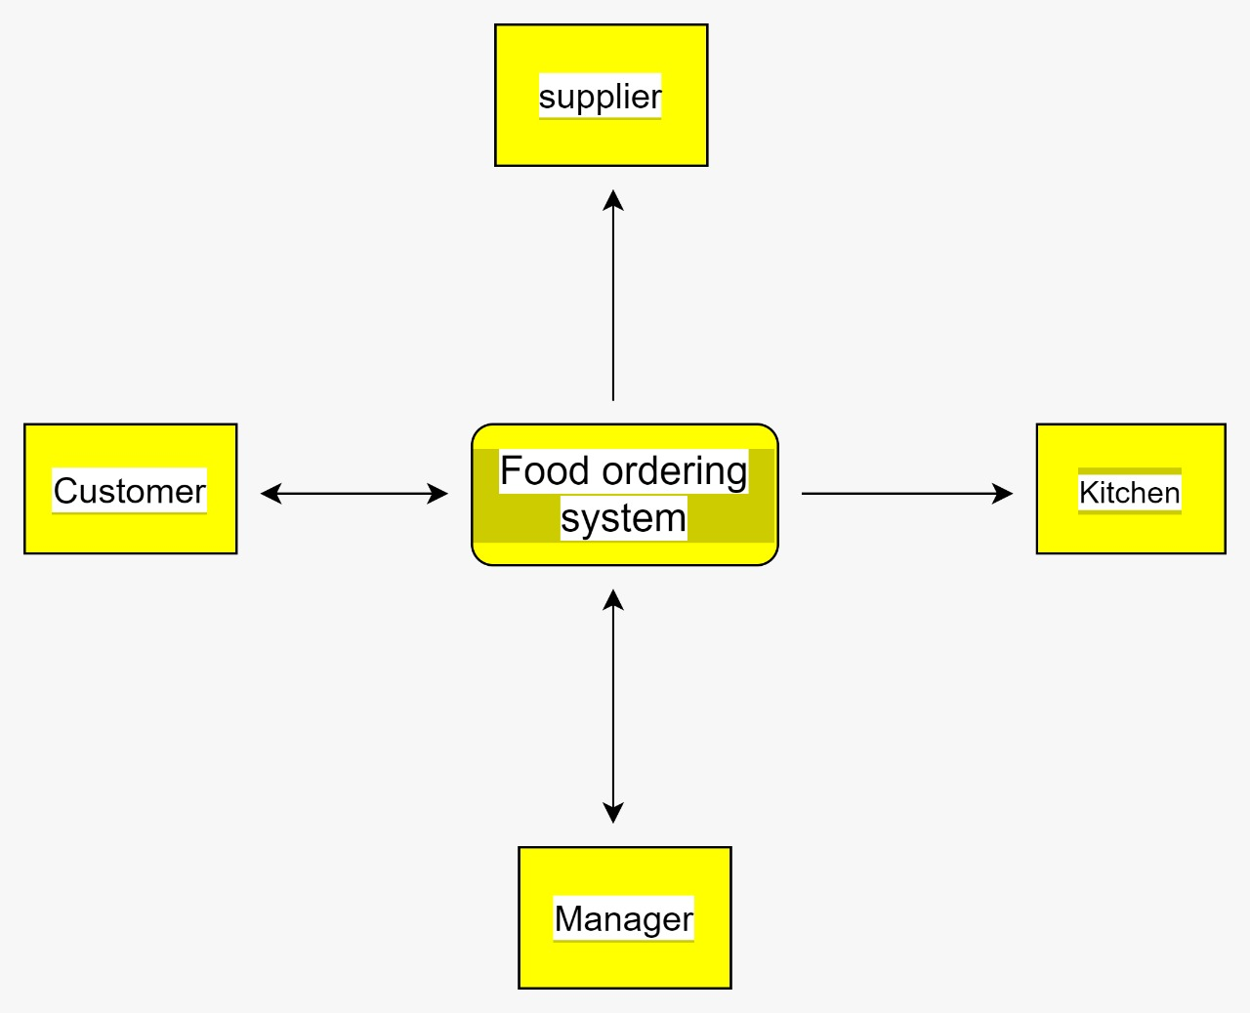

LEVEL 1:-

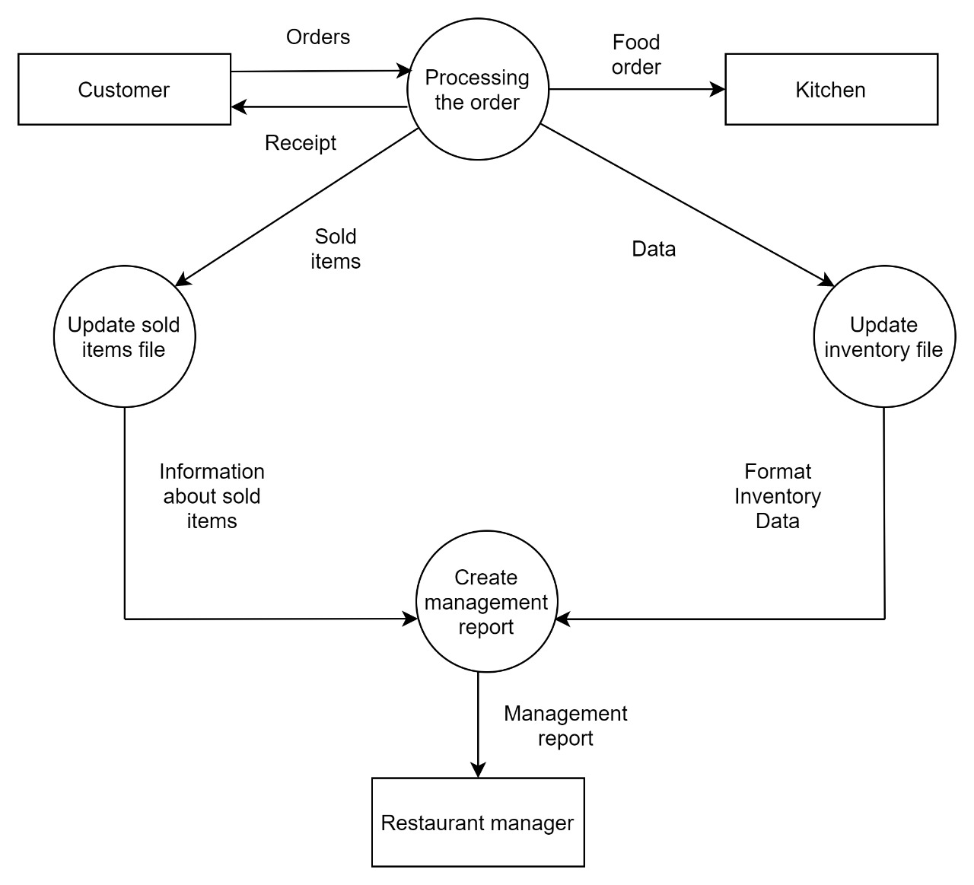

ERD DIAGRAM:-

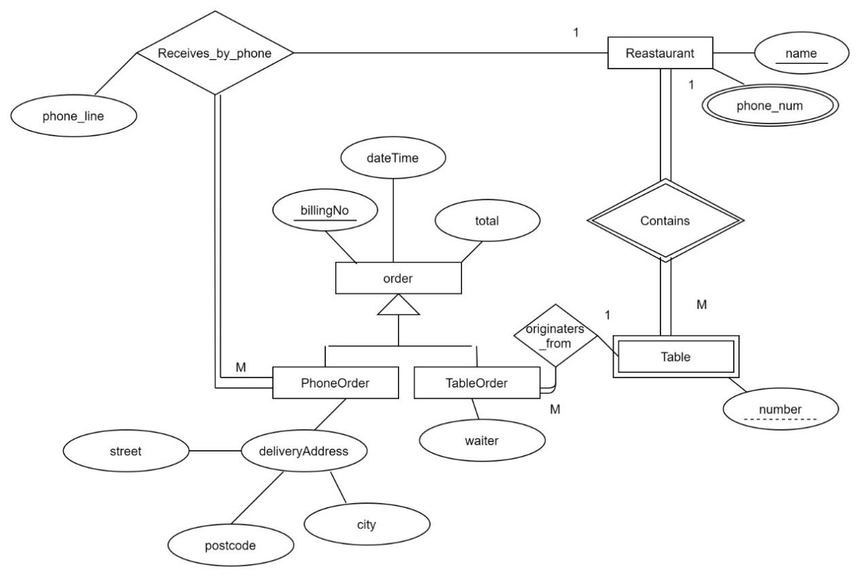

Use Case Diagram:-

